**Problem Statement 1.** Write a program to Display all the prime numbers between 2 and 250.

**Objective:** To write a program that identifies and displays all prime numbers between 2 and 250, enhancing the understanding of prime number algorithms and iteration

techniques.

# Code:

<!DOCTYPE html>

<html lang="en">

<head>

<title>prime number</title>

</head>

<body>

<textarea rows="5"></textarea>

</body>

<script>

function isPrime(num){

if(num <= 1) return false; if(num <= 3) return true;

if(num % 2 == 0 || num % 3 == 0) return false; for(let i = 5; i<=Math.sqrt(num); i += 6){

if(num % i == 0 || num % (i + 2) == 0){ return false;

}

}

return true;

}

let n = 250;

const textArea = document.querySelector('textarea'); for(let i = 2; i<=n; ++i){

if(isPrime(i)){

textArea.textContent += i + ' ';

}

}

</script>

</html>

# Output:

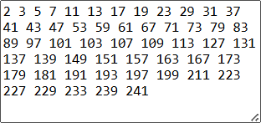

**Problem Statement 2**. Write a Script to find the number of words, characters , vowels and consonant in a string taken as input from user.

**Objective:** To create a script that counts the number of words, characters, vowels, and consonants in a user-provided string, improving string manipulation and regular

expression skills.

# Code:

<!DOCTYPE html>

<html lang="en">

<head>

<title>Document</title>

</head>

<body>

<textarea></textarea>

<button>get data</button>

</body>

<script>

function paraInfo(para) { if (!para) {

console.error('falsi value'); return;

}

if (typeof (para) != 'string') {

console.error('type error: not a string'); return;

}

const wordCount = para.split(/\s+/).length; const characterCount = para.length;

const vowels = ['a', 'e', 'i', 'o', 'u']; para = para.toLowerCase();

let vowelCount = 0;

let consonantCount = 0;

for (let i = 0; i < characterCount; ++i) { let char = para[i];

if (vowels.includes(char)) { vowelCount++;

}

else if (char >= 'a' && char <= 'z') { consonantCount++;

}

}

return {

wordCount, vowelCount,

consonantCount,

}

}

const textArea = document.querySelector('textarea'); const button = document.querySelector('button'); button.addEventListener('click', () => {

alert(JSON.stringify(paraInfo(textArea.value), null, 2));

})

</script>

</html>

**Output:**

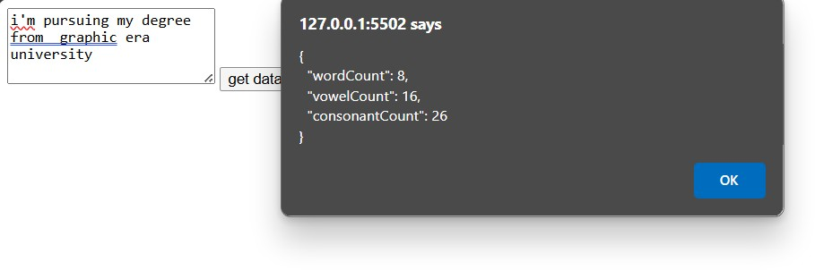

**Problem Statement 3**. Design a web page to open a new window. The new window

should contain test written on it. A confirm box should be displayed on new window to ask the user, whether user wants to close the window or not. If user press OK then close respective window.

**Objective**: To design a web page that opens a new window containing text and

displays a confirm box asking the user whether they want to close the window. If the user presses "OK," the window will close.

# Code:

<!DOCTYPE html>

<html lang="en">

<head>

<meta charset="UTF-8">

<meta name="viewport" content="width=device-width, initial-scale=1.0">

<title>Open New Window</title>

<style> body {

font-family: Arial, sans-serif; padding: 20px;

}

button {

padding: 10px 20px; font-size: 16px; cursor: pointer;

}

</style>

</head>

<body>

<h1>Open a New Window</h1>

<button id="openWindowButton">Open New Window</button>

<script>

document.getElementById('openWindowButton').addEventListener('click', function() { const newWindow = window.open('', '', 'width=400,height=300');

newWindow.document.write('<p>This is the new window.</p>');

newWindow.onbeforeunload = function() {

return 'Are you sure you want to close this window?';

};

newWindow.addEventListener('beforeunload', function(event) { if (!confirm('Do you really want to close this window?')) {

event.preventDefault();

}

});

});

</script>

</body>

</html>

# Output:

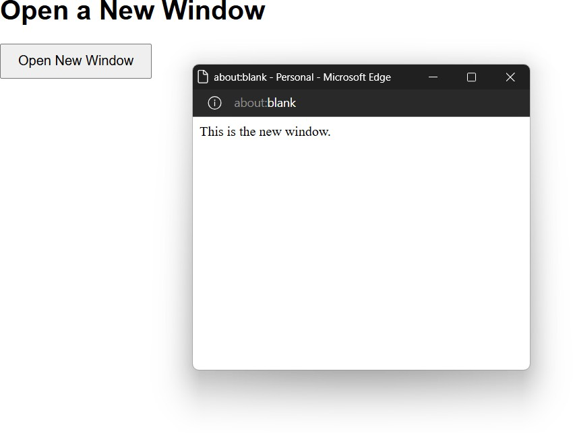

**Problem Statement 4**. Design a webpage to take input from user and display the content on the webpage with Text color RED, background color YELLOW, size 24px. The rest of the text should not be changed within the paragraph.

**Objective:** To design a webpage that takes user input and displays it with specific text color, background color, and font size, while keeping the rest of the paragraph unchanged, improving CSS styling and DOM manipulation skills.

# Code:

<!DOCTYPE html>

<html lang="en">

<head>

<title>Document</title>

</head>

<body>

<form onsubmit="insertText()">

<input type="text" placeholder="what's on your mind">

<input type="submit" value="submit">

</form>

<p>

here is your paragraph

<span id="highlight" style="background: yellow; color: red"></span>

</p>

</body>

<script>

const highlight = document.getElementById('highlight'); const textInput = document.querySelector('input');

const form = document.querySelector('form'); form.onsubmit = insertText;

function insertText(e){

console.log(e);

e.preventDefault();

highlight.textContent = textInput.value; textInput.value = '';

}

</script>

</html>

# Output:

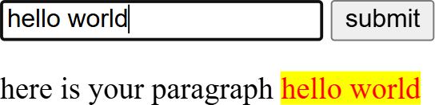

**Problem Statement 5**. Design a registration form and using javascript provide the following validation:

1. No field should be left blank.
2. Age should contain only numeric value.
3. Age should be greater than 18.
4. Name should not contain any special character or numbers.

**Objective:** To design a registration form with JavaScript validation to ensure no field is left blank, age contains only numeric values and is greater than 18, and name does not

contain any special characters or numbers, enhancing form validation and user input handling skills.

# Code:

<!DOCTYPE html>

<html>

<head>

<title>Form Validation</title>

<style>

*{

margin: 0;

padding: 0;

box-sizing: border-box; font-family: sans-serif;

}

body{

width: 100vw;

min-height: 100svh; display: flex;

align-items: center; justify-content: center;

}

form{

min-width: 380px; padding: 20px;

border-radius: 20px; background-color: white; display: flex;

flex-direction: column; gap: 8px;

box-shadow: 0px 0px 20px rgba(0, 0, 0, 0.283);

}

input{

padding: 8px 16px; border-radius: 8px;

border-color: rgba(65, 105, 225, 0.269);

}

input:focus{

outline-color: royalblue;

}

input[type='submit']{

background-color: royalblue; color: white;

font-weight: 600; font-size: 18px;

}

input[type='submit']:hover{ filter: brightness(110%); cursor: pointer;

}

</style>

</head>

<body>

<form>

<input type="text" id="name" placeholder="Name">

<input type="number" id="age" placeholder="age">

<input type="submit" value="submit">

</form>

</body>

<script>

const form = document.querySelector('form');

const nameInput = document.getElementById('name'); const ageInput = document.getElementById('age');

form.addEventListener('submit', (e)=>{ e.preventDefault();

const name = nameInput.value.trim(); const age = +ageInput.value;

// check if any field is blank if(!name || !ageInput.value){

alert('All fields are required'); return;

}

// validating age

if(isNaN(age) || age <= 18){

alert('Age must be grether than 18'); return;

}

// check apecial symbol

const regex = /^[a-zA-z\s]+$/;

if(!regex.test(name)){

alert('Name must not contain any special symbol'); return;

}

alert('form submitted successfully'); form.submit();

})

</script>

</html>

# Output:

